Five-Pointed Star
# Source: AI Source: Provided by: [Data Path: Persons Table -> ID Column: 1, Name_En Column: Motasem Essam] -> From: [ChatGPT] on [7/25/2026]
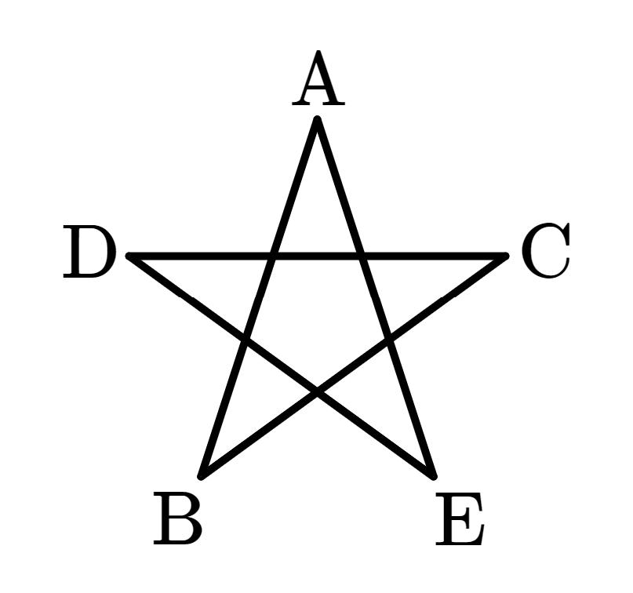
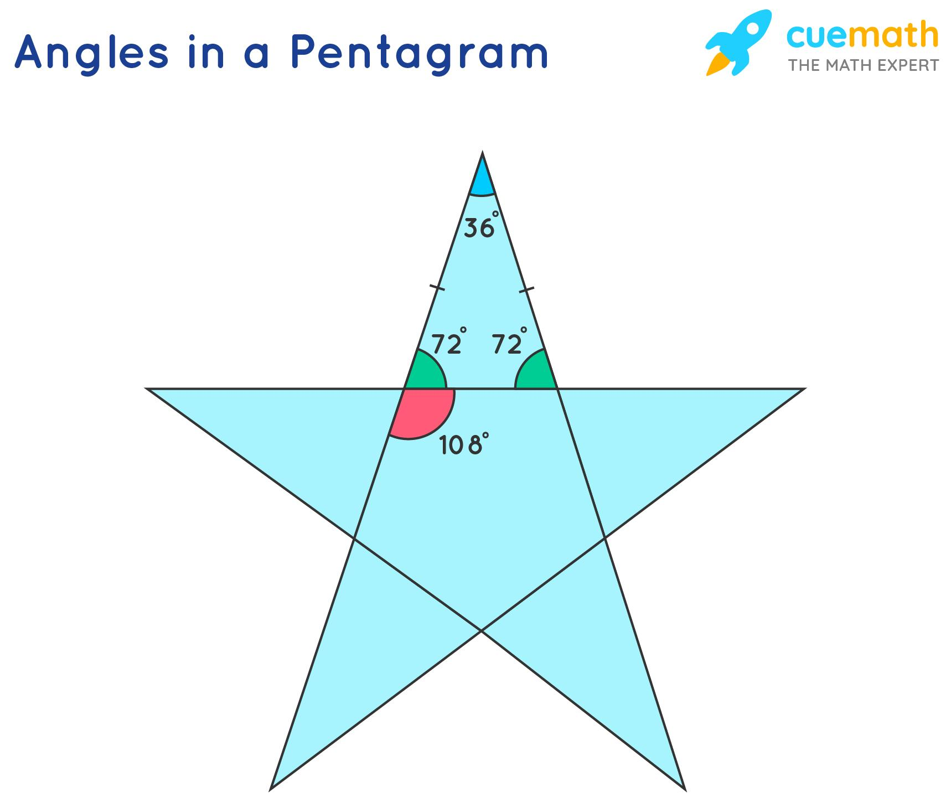
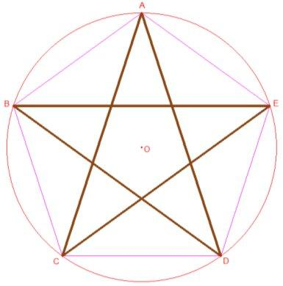
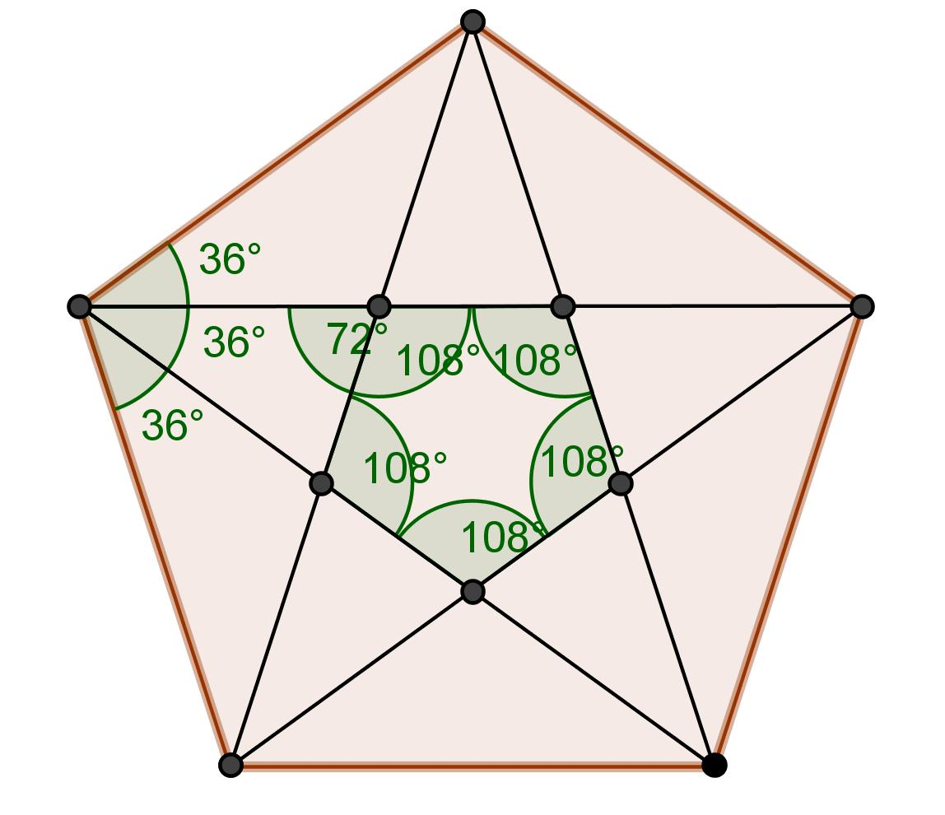
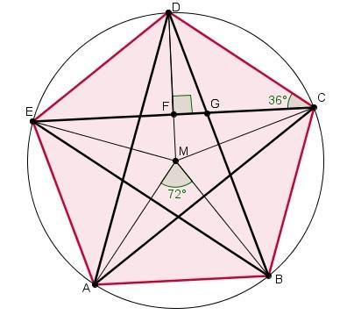

Definition
# Source: AI Source: Provided by: [Data Path: Persons Table -> ID Column: 1, Name_En Column: Motasem Essam] -> From: [ChatGPT] on [7/25/2026]
A Five-Pointed Star is a star-shaped geometric figure with five outer points arranged around a central region.
When its five vertices are connected in a crossing pattern, it forms a Pentagram, which is a self-intersecting star polygon.
The regular crossed form is represented by:
$$\boxed{\left\{5/2\right\}}$$
where:
- $5$= number of vertices
- $2$= connect every second vertex
Thus:
$$\boxed{\text{Five-Pointed Star}→\text{Pentagram}→\text{Crossed Star Polygon}}$$

Fundamental Elements
# Source: AI Source: Provided by: [Data Path: Persons Table -> ID Column: 1, Name_En Column: Motasem Essam] -> From: [ChatGPT] on [7/25/2026]
A regular five-pointed star has:
- 5 outer points
- 5 inner regions/indentations
- 5 main vertices
- 5-fold rotational symmetry
- 5 lines of reflection symmetry
- A central pentagonal region in the regular pentagram
- 5 self-intersection points in the pentagram construction

Construction
# Source: AI Source: Provided by: [Data Path: Persons Table -> ID Column: 1, Name_En Column: Motasem Essam] -> From: [ChatGPT] on [7/25/2026]
A regular pentagram can be constructed from a regular pentagon.
- Construct a regular pentagon.
- Label its vertices $A,B,C,D,E$.
- Connect every second vertex:
$$A→C→E→B→D→A$$
The resulting figure is a pentagram.
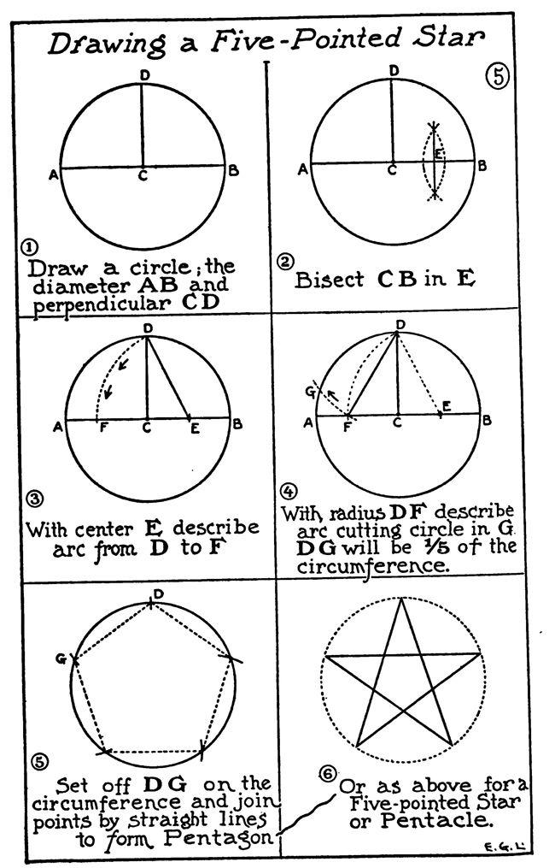
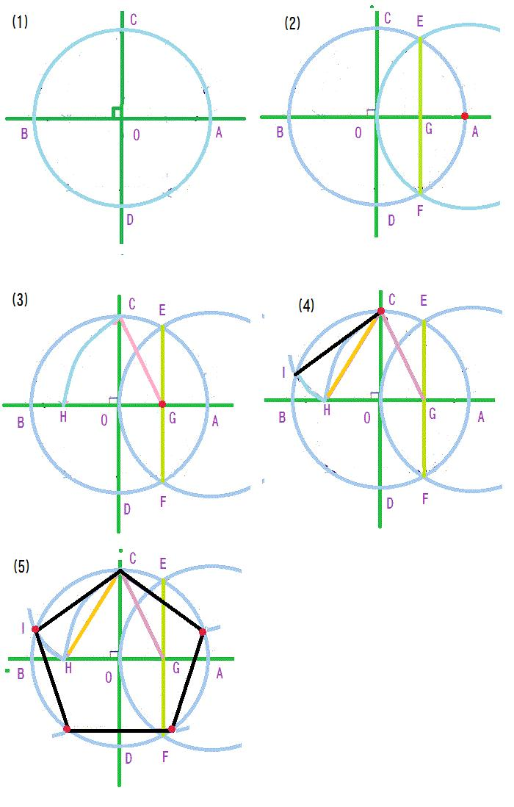
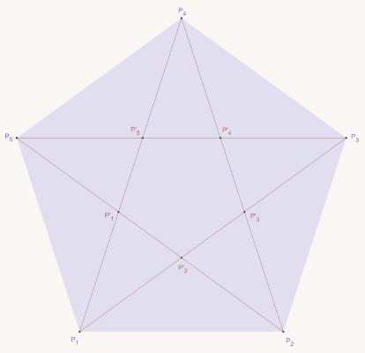
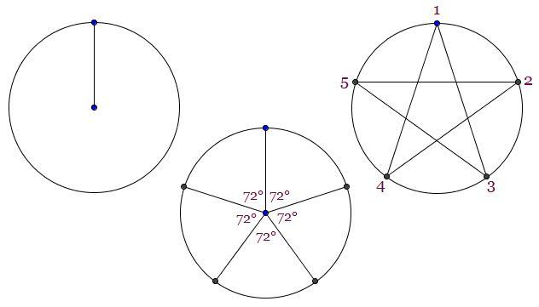
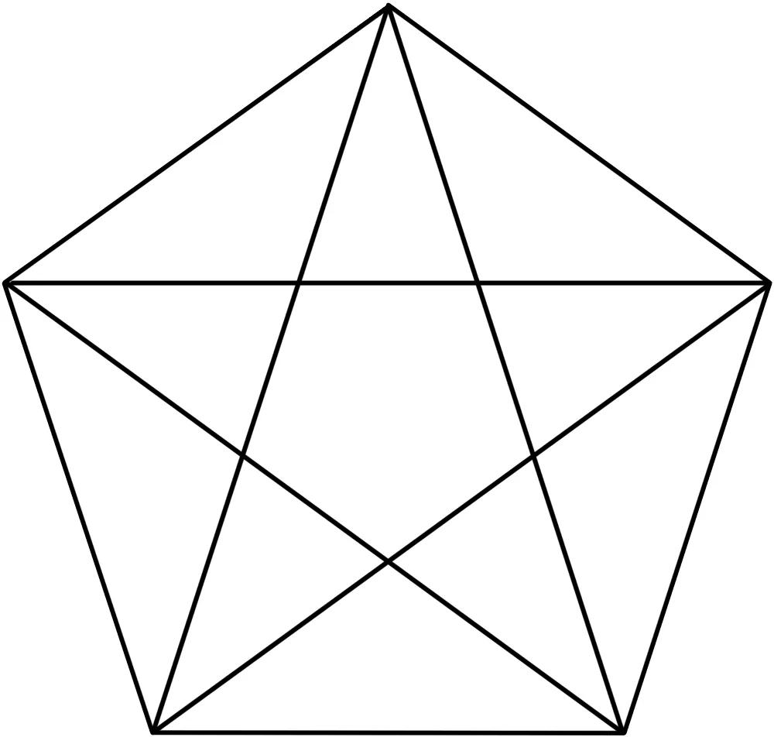

Mathematical Representation
# Source: AI Source: Provided by: [Data Path: Persons Table -> ID Column: 1, Name_En Column: Motasem Essam] -> From: [ChatGPT] on [7/25/2026]
The regular five-pointed star polygon is:
$$\boxed{\left\{5/2\right\}}$$
The notation means:
$$n=5, k=2$$
where $n$is the number of vertices and $k$specifies the connection step.
Because:
$$gcd⁡\left(5 , 2\right)=1$$
the construction produces one continuous star polygon.

Angles
# Source: AI Source: Provided by: [Data Path: Persons Table -> ID Column: 1, Name_En Column: Motasem Essam] -> From: [ChatGPT] on [7/25/2026]
A regular pentagram is based on a regular pentagon.
The central angle between adjacent pentagon vertices is:
$$\frac{{360}^{∘}}{5}={72}^{∘}$$
Therefore:
$$\boxed{{72}^{∘}}$$
is the fundamental rotational angle.
The acute angle at each outer point of a regular pentagram is:
$$\boxed{{36}^{∘}}$$

Symmetry
# Source: AI Source: Provided by: [Data Path: Persons Table -> ID Column: 1, Name_En Column: Motasem Essam] -> From: [ChatGPT] on [7/25/2026]
The regular five-pointed star has:
Rotational Symmetry
Its rotational symmetry order is:
$$\boxed{5}$$
The smallest non-zero angle of rotation is:
$$\boxed{{72}^{∘}}$$
because:
$$\frac{{360}^{∘}}{5}={72}^{∘}$$
Reflection Symmetry
A regular five-pointed star has:
$$\boxed{5}$$
lines of reflection symmetry.

Golden Ratio
# Source: AI Source: Provided by: [Data Path: Persons Table -> ID Column: 1, Name_En Column: Motasem Essam] -> From: [ChatGPT] on [7/25/2026]
The regular pentagram has an important relationship with the Golden Ratio:
$$\boxed{φ=\frac{1+\sqrt{5}}{2}}$$
with approximately:
$$φ≈1.618$$
Various lengths in a regular pentagram occur in golden-ratio relationships.
For example, certain segments satisfy:
$$\boxed{\frac{a}{b}=φ}$$
This is one of the most famous mathematical properties of the pentagram.

Perimeter
# Source: AI Source: Provided by: [Data Path: Persons Table -> ID Column: 1, Name_En Column: Motasem Essam] -> From: [ChatGPT] on [7/25/2026]
If the five star edges have equal length $s$, then:
$$\boxed{P=5s}$$
For example, if:
$$s=4\text{ cm}$$
then:
$$P=5\left(4\right)=20\text{ cm}$$

Area
# Source: AI Source: Provided by: [Data Path: Persons Table -> ID Column: 1, Name_En Column: Motasem Essam] -> From: [ChatGPT] on [7/25/2026]
The area of a five-pointed star depends on its construction and on which region is being measured.
For a regular star, it can be calculated by:
- decomposing the figure into triangles;
- calculating the outer and inner regions;
- using coordinates;
- applying appropriate polygon-area methods.
If the star is represented as a self-intersecting polygon, the signed area and the geometric area of the visible star region may not be the same.
Therefore:
$$\boxed{\text{The area requires a specified geometric interpretation}}$$

Example
# Source: AI Source: Provided by: [Data Path: Persons Table -> ID Column: 1, Name_En Column: Motasem Essam] -> From: [ChatGPT] on [7/25/2026]
Suppose a regular five-pointed star has equal outer-edge length:
$$s=6\text{ cm}$$
Its perimeter is:
$$P=5s \\ P=5\left(6\right) \\ \boxed{P=30\text{ cm}}$$
Its rotational symmetry angle is:
$$θ=\frac{{360}^{∘}}{5} \\ \boxed{θ={72}^{∘}}$$

Five-Pointed Star vs. Pentagram
# Source: AI Source: Provided by: [Data Path: Persons Table -> ID Column: 1, Name_En Column: Motasem Essam] -> From: [ChatGPT] on [7/25/2026]
These terms are related but should not always be treated as identical.
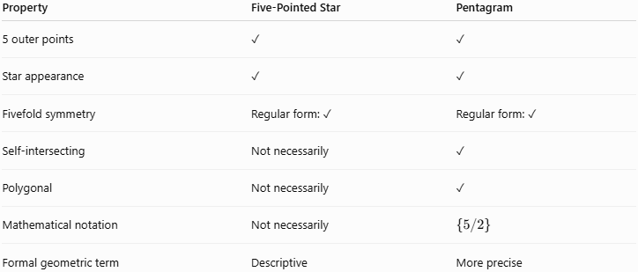
Property | Five-Pointed Star | Pentagram
5 outer points | ✓ | ✓
Star appearance | ✓ | ✓
Fivefold symmetry | Regular form: ✓ | Regular form: ✓
Self-intersecting | Not necessarily | ✓
Polygonal | Not necessarily | ✓
Mathematical notation | Not necessarily | $$\left\{5/2\right\}$$
Formal geometric term | Descriptive | More precise
A filled five-pointed star symbol does not necessarily represent a pentagram.
A pentagram specifically refers to the self-intersecting polygonal construction.

Relationship with Crossed Star Shapes
# Source: AI Source: Provided by: [Data Path: Persons Table -> ID Column: 1, Name_En Column: Motasem Essam] -> From: [ChatGPT] on [7/25/2026]
The classification for your knowledge base can be:
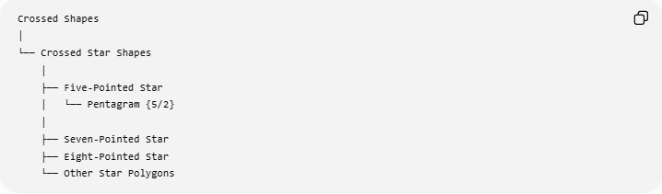
Crossed Shapes
│
└── Crossed Star Shapes
│
├── Five-Pointed Star
│ └── Pentagram {5/2}
│
├── Seven-Pointed Star
├── Eight-Pointed Star
└── Other Star Polygons
For the mathematical polygon classification:
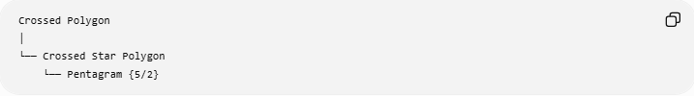
Crossed Polygon
│
└── Crossed Star Polygon
└── Pentagram {5/2}

Relationship with the Regular Pentagon
# Source: AI Source: Provided by: [Data Path: Persons Table -> ID Column: 1, Name_En Column: Motasem Essam] -> From: [ChatGPT] on [7/25/2026]
The pentagram can be constructed from a regular pentagon by connecting every second vertex.
$$\boxed{\text{Regular Pentagon}→\text{Pentagram}}$$
This gives the pentagram its fivefold symmetry and its connection to the Golden Ratio.

Real-World Applications
# Source: AI Source: Provided by: [Data Path: Persons Table -> ID Column: 1, Name_En Column: Motasem Essam] -> From: [ChatGPT] on [7/25/2026]
Five-pointed stars are commonly used in:
- Symbols
- Flags
- Logos
- Decorative patterns
- Architecture
- Art
- Graphic design
- Mathematical illustrations
- Computer graphics

Advantages
# Source: AI Source: Provided by: [Data Path: Persons Table -> ID Column: 1, Name_En Column: Motasem Essam] -> From: [ChatGPT] on [7/25/2026]
- Highly symmetric.
- Easy to recognize.
- Provides an important example of a self-intersecting polygon.
- Demonstrates rotational and reflection symmetry.
- Provides a classic example of the Golden Ratio.

Limitations
# Source: AI Source: Provided by: [Data Path: Persons Table -> ID Column: 1, Name_En Column: Motasem Essam] -> From: [ChatGPT] on [7/25/2026]
- A five-pointed star is not always a mathematically precise term.
- A decorative star does not necessarily represent a pentagram.
- Area calculations can become ambiguous for the self-intersecting form.
- Different constructions can produce visually similar five-pointed stars.

Comparison with Related Shapes
# Source: AI Source: Provided by: [Data Path: Persons Table -> ID Column: 1, Name_En Column: Motasem Essam] -> From: [ChatGPT] on [7/25/2026]
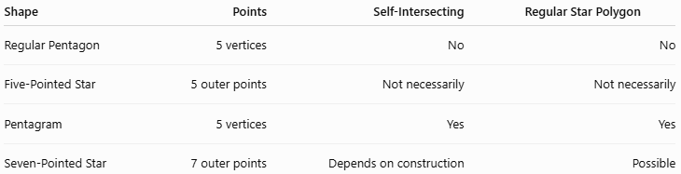
Shape | Points | Self-Intersecting | Regular Star Polygon
Regular Pentagon | 5 vertices | No | No
Five-Pointed Star | 5 outer points | Not necessarily | Not necessarily
Pentagram | 5 vertices | Yes | Yes
Seven-Pointed Star | 7 outer points | Depends on construction | Possible

Key Points
# Source: AI Source: Provided by: [Data Path: Persons Table -> ID Column: 1, Name_En Column: Motasem Essam] -> From: [ChatGPT] on [7/25/2026]
- A Five-Pointed Star has five outer points.
- Its regular crossed polygonal form is the Pentagram.
- The pentagram is represented by:
$$\boxed{\left\{5/2\right\}}$$
- It has rotational symmetry of order:
$$\boxed{5}$$
- Its smallest rotational angle is:
$$\boxed{{72}^{∘}}$$
- A regular pentagram has 5 reflection symmetries.
- The outer point angle of a regular pentagram is:
$$\boxed{{36}^{∘}}$$
- The pentagram has important relationships with the Golden Ratio.

Conclusion
# Source: AI Source: Provided by: [Data Path: Persons Table -> ID Column: 1, Name_En Column: Motasem Essam] -> From: [ChatGPT] on [7/25/2026]
The Five-Pointed Star is the most familiar member of the crossed star-shape family. Its precise mathematical crossed-polygon form is the Pentagram $\left\{5/2\right\}$, created by connecting every second vertex of a regular pentagon.
$$\boxed{\text{Crossed Shapes}→\text{Crossed Star Shapes}→\text{Five-Pointed Star}→\text{Pentagram }\left\{5/2\right\}}$$

